Name : N.Deepthi
H.T NO : 2303A51354
Lab 3: Application for TGNPDCL – Electricity Bill Generation Using Python &
AI Tools
Task 1: AI-Generated Logic for Reading Consumer Details
Scenario
An electricity billing system must collect accurate consumer data.
Task Description
Use an AI tool (GitHub Copilot / Gemini) to generate a Python program that:
• Reads:
- Previous Units (PU)
- Current Units (CU)
- Type of Customer
• Calculates units consumed
• Implements logic directly in the main program (no functions)
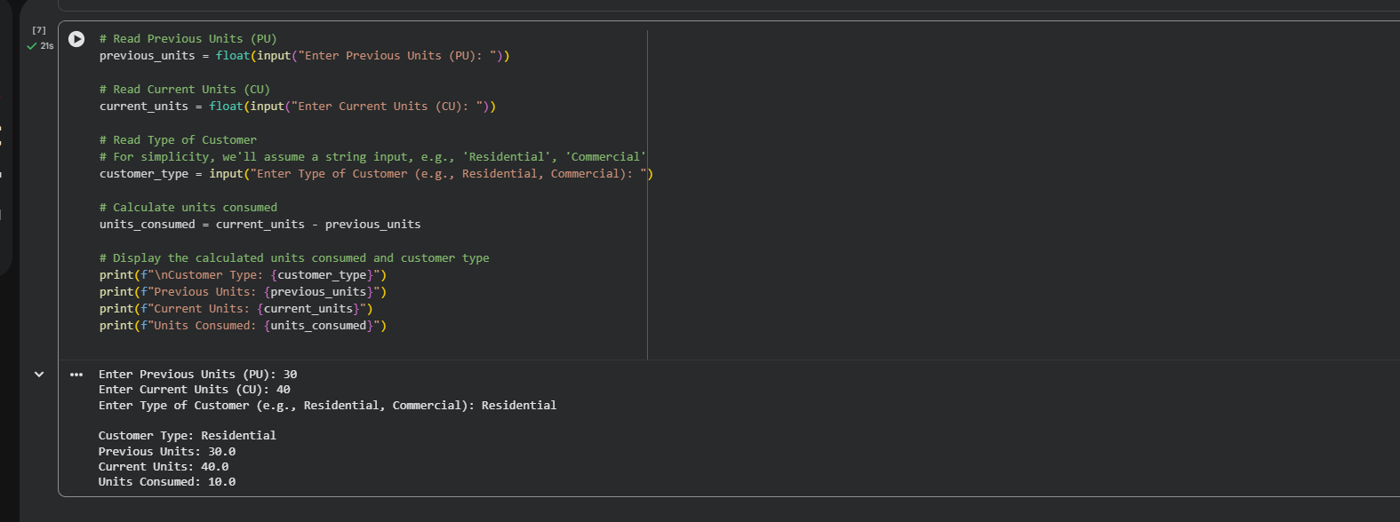
Task 2: Energy Charges Calculation Based on Units Consumed
Scenario:
Energy charges depend on the number of units consumed and customer type.
Task Description:
Review the AI-generated code from Task 1 and extend it to:
• Calculate Energy Charges (EC)
• Use conditional statements based on:
- Domestic
- Commercial
- Industrial consumers
• Improve readability using AI prompts such as:
- “Simplify energy charge calculation logic”
- “Optimize conditional statements”
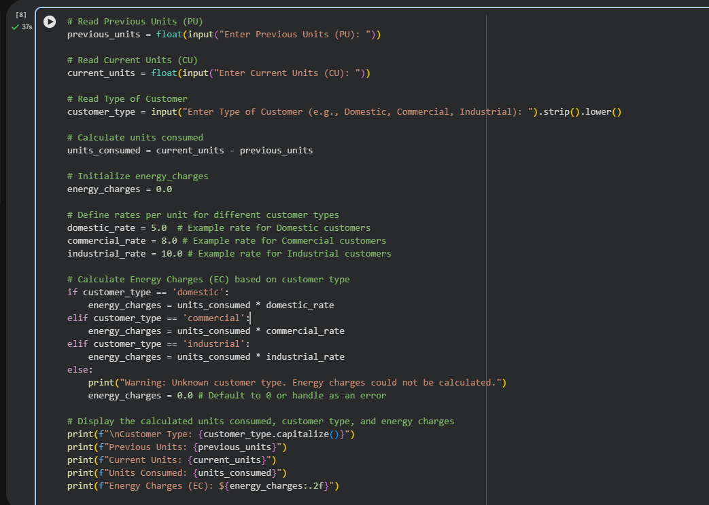
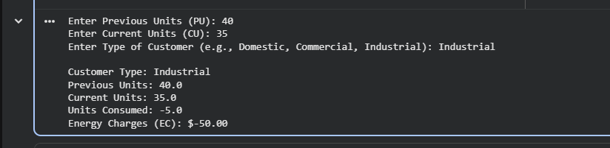
Task 3: Modular Design Using AI Assistance (Using Functions)
Scenario:
Billing logic must be reusable for multiple consumers.
Task Description:
Use AI assistance to generate a Python program that:
• Uses user-defined functions to:
  - Calculate Energy Charges
  - Calculate Fixed Charges
• Returns calculated values
• Includes meaningful comments
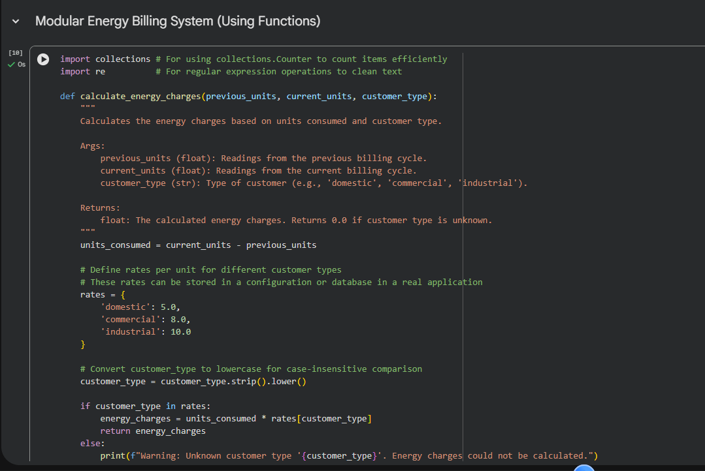
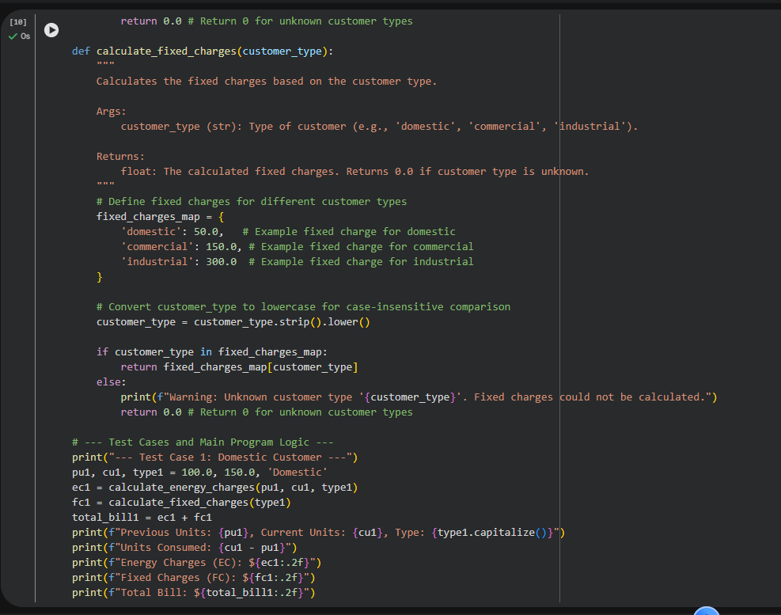
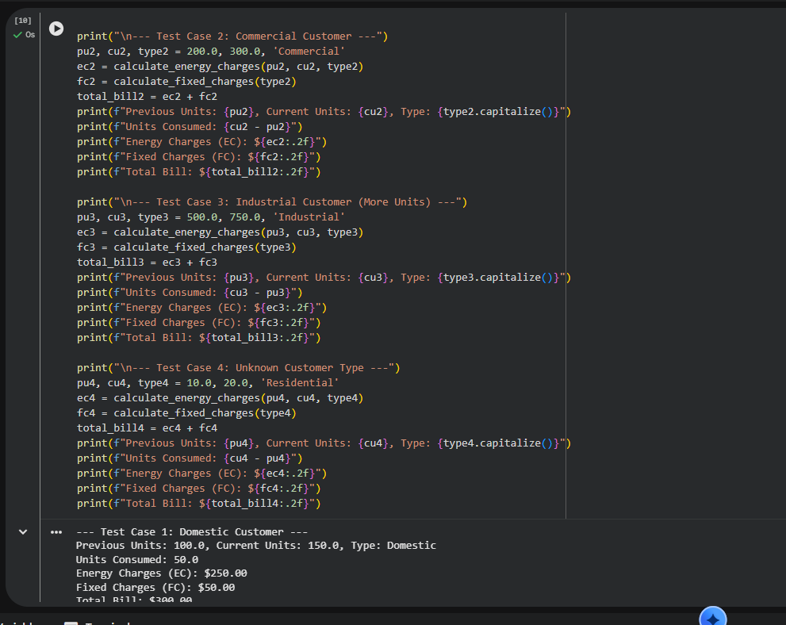
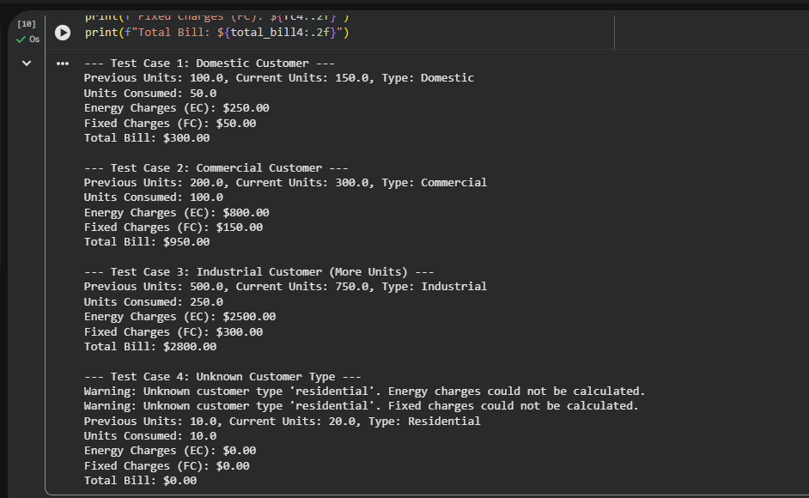
Task 4: Calculation of Additional Charges
Scenario :
Electricity bills include multiple additional charges.
Task Description :
Extend the program to calculate:
    - FC – Fixed Charges
    - CC – Customer Charges
    - ED – Electricity Duty (percentage of EC)
Use AI prompts like:
    - “Add electricity duty calculation”
    - “Improve billing accuracy”
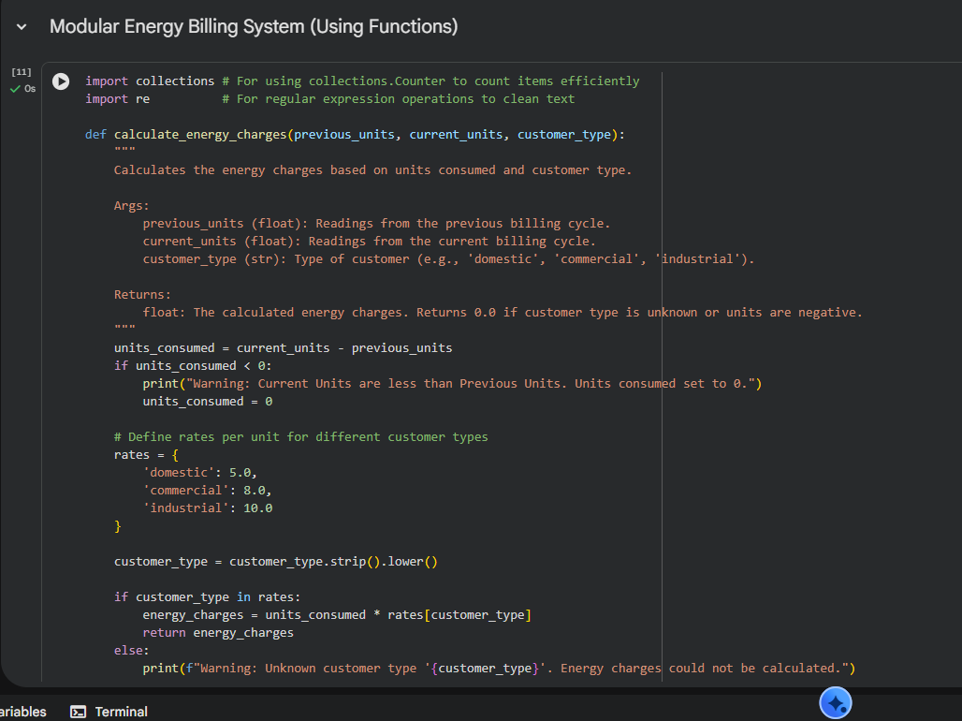
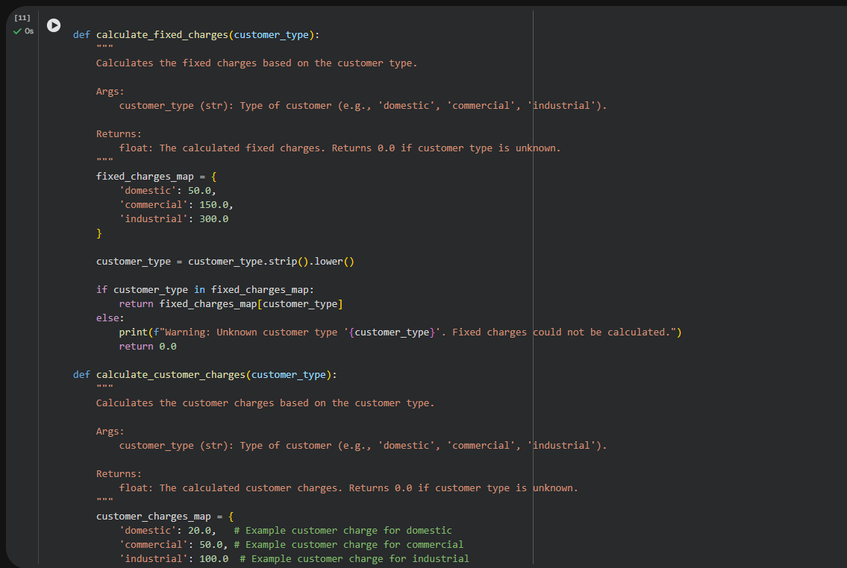
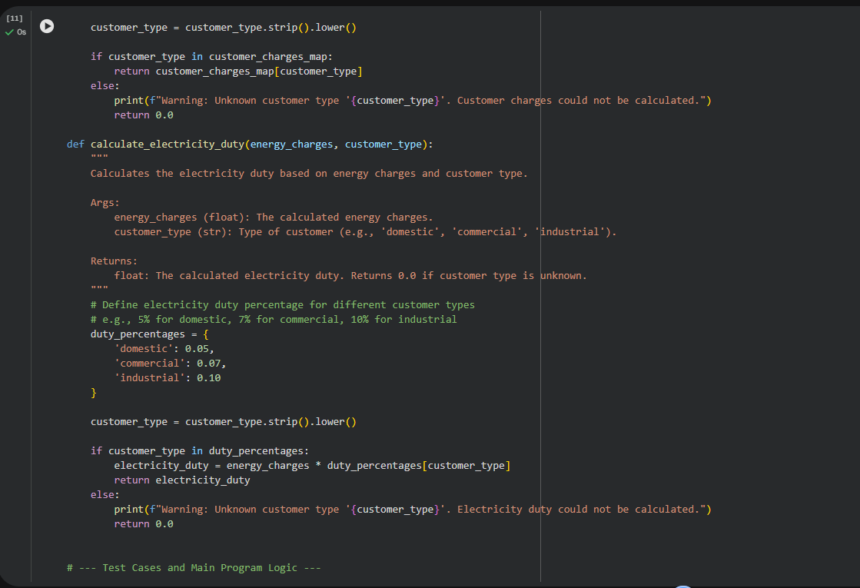
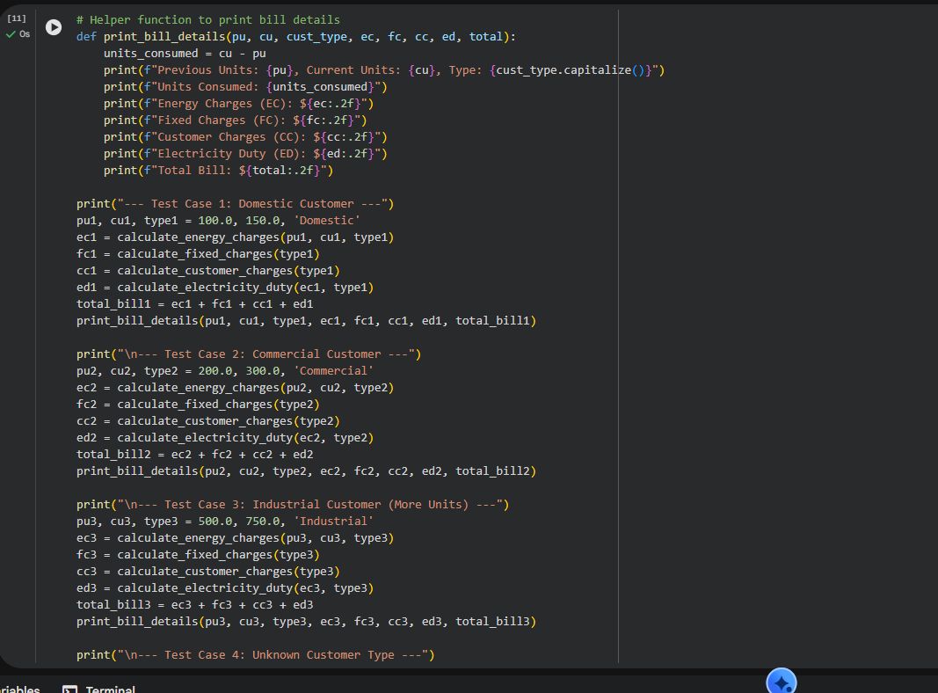
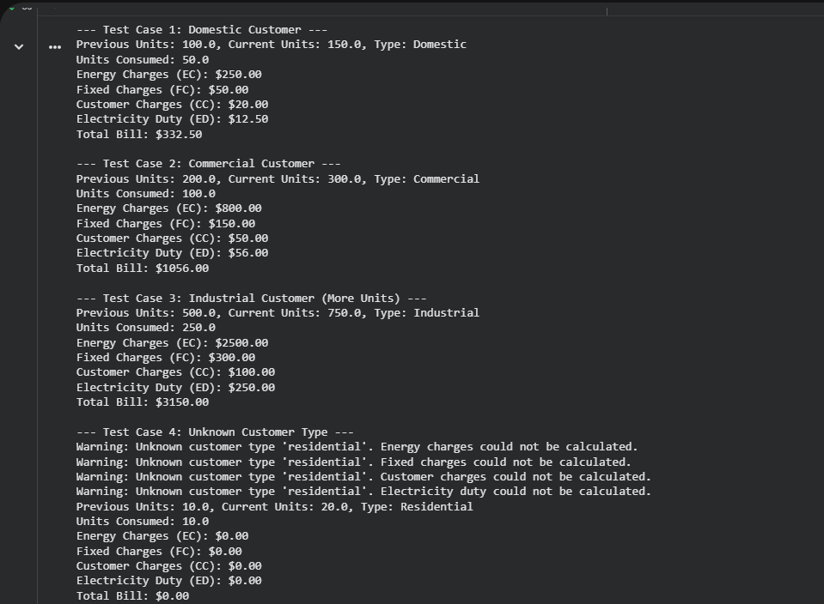
Task 5: Final Bill Generation and Output Analysis
Scenario :
The final electricity bill must present all values clearly.
Task Description :
Develop the final Python application to:
• Calculate total bill:
• Total Bill = EC + FC + CC + ED
• Display:
  - Energy Charges (EC)
  - Fixed Charges (FC)
  - Customer Charges (CC)
  - Electricity Duty (ED)
  - Total Bill Amount
• Analyze the program based on:
  - Accuracy
  - Readability
  - Real-world applicability
